**Lesson 5 – Assignment Hung Le**

**Chapter 9 – Question 6**

const prompt = require("prompt-sync")();

let a = parseFloat(prompt("Please enter the triangle's length a: "));

let b = parseFloat(prompt("Please enter the triangle's length b: "));

let c = parseFloat(prompt("Please enter the triangle's length c: "));

let width = parseFloat(prompt("Please enter the width: "));

let depth = parseFloat(prompt("Please enter the depth: "));

let height = parseFloat(prompt("Please enter the height: "));

let sweep = parseFloat(prompt("Please enter the sweep: "));

function triangleArea(a, b, c) {

let s = (a + b + c) / 2;

let triangle_area = Math.sqrt(s * (s - a) * (s - b) * (s - c));

console.log("triangle area is "+triangle_area);

return triangle_area;

}

function roofVolume(width, depth, sweep) {

let roof_volume = triangleArea(a, b, c) * width;

console.log ("roof volume is "+roof_volume);

return roof_volume;

}

function livingVolume(width, depth, height) {

let living_volume = width * depth * height;

console.log("living volume is " + living_volume);

return living_volume;

}

function houseVolume(width, depth, height, sweep) {

let house_volume = livingVolume(width, depth, height) + roofVolume(width, depth, sweep);

return house_volume;

}

console.log("house volume is "+houseVolume(width, depth, height, sweep));

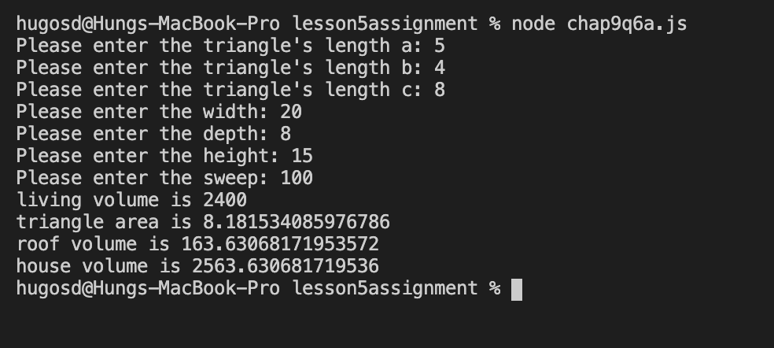

1. **Write a function named checkPrime that accepts a parameter and returns true if the argument is a prime number otherwise returns false**

const prompt = require("prompt-sync")();

function checkPrime() {

let num = parseInt(prompt("Please enter a number: "));

if (num <= 1)

console.log("This number is not a prime number");

else if (num === 2)

console.log("This number is a prime number");

else {

for (i = 2; i < num; i++) {

if (num % i === 0) {

console.log("This number is not a prime number");

break;

}

}

if (i === num)

console.log("This number is a prime number");

}

}

checkPrime()

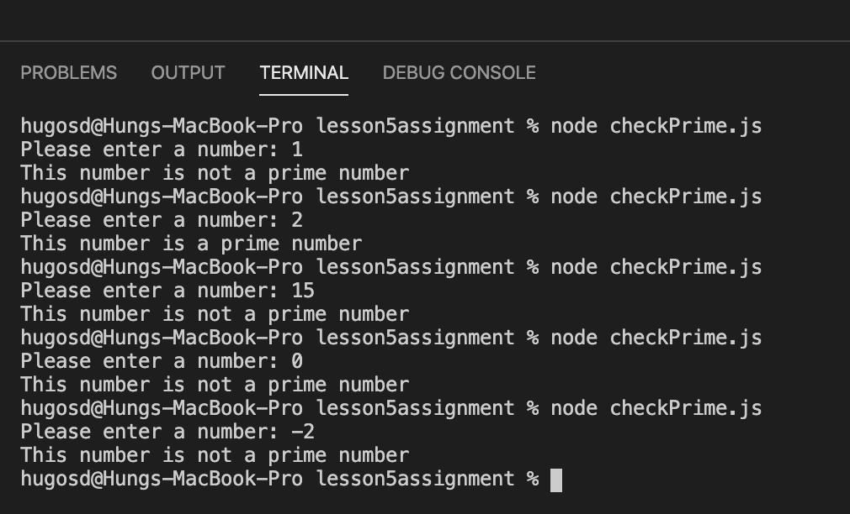

1. **Write a function farhToCels that accepts a parameter for temperature in degree Fahrenheit and returns temperature in degree Celsius.**

const prompt = require("prompt-sync")();

function farthToCels() {

let tempInFahrenheit = prompt("Please enter a temperature value in degree Fahrenheit: ")

let tempInCelsius = (parseFloat(tempInFahrenheit)-32)*5/9;

console.log(tempInCelsius);

}

farthToCels();

